GGN - Geopark Annual Report 2020

1. GEOPARK IDENTITY
Geopark name, country, regional Network:：Arxan UNESCO Global Geopark (China, APGN)
Year of inscription / Year of the last revalidation: 2016
Representative Photo (from the most important event this year)

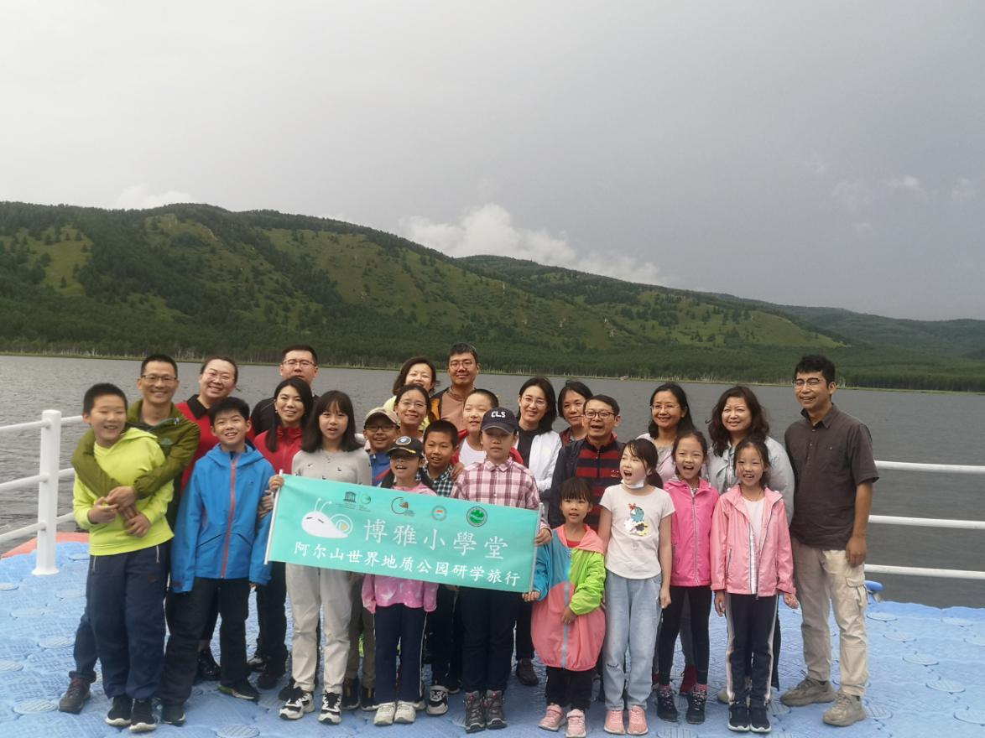
Study Tourism of Arxan UGGp in Aug. 2020
2. GEOPARK FIGURES
Number of Geopark staffs:24 staffs including，9 geoscientists,7 employee.
Number of Visitors:2.6 million.
Number of Geopark events:
- Axran International Health & Ice Festival；
- World Earth Day；
- Exchanged with Guangwushan-Nuoshuihe、Yimengshan UNESCO Global Geopark；
- Primary and secondary science activities；
- Study Tourism of Arxan UGGp
Number school classes realize Geopark educational programmes: 3
Number of Geopark press release:32
3. GEOPARK ACTIVITIES
Main Achievements in 2020
Exchanged with Guangwushan-Nuoshuihe、Yimengshan UNESCO Global Geopark ;Protective fence and boardwalk、science propaganda promenade for construction and maintenance in main geoheritage of Arxan Geopark；Arxan Geopark further improved the basic service facilities、identification system and commentary system in Geopark；Construction of the Arxan UNESCO Global Geopark Gaoshan Scientific Investigation Station.
Contribution towards GGN - Networking and Participation
Took part in the 6th International Training Course on UNESCO Global Geoparks Management and Development;Took part in GGN Annual Meeting; And other Online meeting in APGN.
Management and Financial status
The Administration for Arxan Globall Geopark established in 2009 is the management body of the geopark, which oversees all aspects of geopark development, including conservation, planning, research, science popularization, promotion, day-to-day management and tourist services. Currently, the administration has 26 staffs in total to carry out its various functions.
The tourism revenue in 2020 is2.6 billion RMB.
Geoconservation
Geoconservation work is carried out by designated staff in areas where representative geoheritages are distributed, such as the turtleback lava and Tuoengling Tianchi Crater Lake. To avoid damage of geoheritages by visitors, the geopark has erected protective fences around geosites. There are geosite protection boardwalks at the turtleback lava to prevent trampling;Construction of the Arxan UNESCO Global Geopark Gaoshan Scientific Investigation Station.
Sustainable development (Geotourism)
Day reception capacity of more than 1,000 persons; Geopark tourist guide more than100 persons.
New Education programmes on geoconservation, sustainable development and disaster risk reduction
The Arxan Geopark has formulated the 2020 annual geological heritage protection and popular science education work plan; launched the Earth Day special exhibition and popular science report meeting; Compiled the Arxan Geopark Plan (2018-2035)
Geopark Partners
Cooperate with China University of Geosciences, Beijing、Arxan Tianquan Souvenirs Company、 local hotels、local tourism commodity company and TV station、 Inner Mongolia TV station, etc.
Tourism Promotion Activities
The Arxan UNESCO Global Geopark image video in CCTV1 and Inner Mongolia CCTV 、Took part in China Tourism Industry Fair 2020 、Arxan Winter Tourism Promotion、Beijing International Health Tourism Expo 、Four Seasons Scenery of Arxan Photography Exhibition in Beijing.
4. Contact Persons
Manager: Rongshan Cheng，aesdzgyglj@163.com
Geologist: Mingzhong Tian，1085250594@qq.com

